Swallowing problems after stroke

Swallowing problems are very common after a stroke. If your swallowing has been affected, this guide can help you understand what you need to do.

It’s aimed at people who have had a stroke but there is information for family and friends as well.

Find more useful information and practical tips at
stroke.org.uk, or call our Stroke Support Helpline for printed copies.
Useful topics include:
• Communication problems after a stroke stroke.org.uk/communication-problems
• Physical effects of stroke stroke.org.uk/physical-effects
• Emotional changes after a stroke stroke.org.uk/emotional-changes

What’s in this guide?

- Why can’t I swallow? 3
- Are there treatments that can help? 11
- Tube feeding 19
- What can I do about swallowing problems? 26
- Tips for family and friends 33
- Where to get help and information 37

Why can’t I swallow?

Swallowing is a complicated task that needs your brain to coordinate many different muscles in the mouth and throat. If your stroke damages the parts of your brain that do this, then this will affect your ability to swallow. Swallowing problems are also known as dysphagia.

Other effects of stroke can make eating, drinking and swallowing difficult too. If your arm or hand has been affected by your stroke, you may not be able to use a spoon or a cup properly. This can affect the way you swallow. If your face or lip muscles are affected, you might find that saliva (spit) escapes from your mouth.

If your balance has been affected, you may not be able to sit up straight, which can make swallowing more difficult. If you’re drowsy or not able to concentrate very well, then you may not swallow your food in the right way

There are several stages to swallowing. A stroke can affect any one of these stages. See page 9 to learn how swallowing works.

Can swallowing problems make you unwell?
If you have difficulty swallowing, food and drink may be getting into your airway and lungs. Even saliva (spit) can enter the airway if someone is not able to swallow properly, or if they are drowsy and cannot cough normally. This is called aspiration.

Aspiration can be very serious. Your mouth contains high numbers of bacteria (germs) and if these enter the airway, it can lead to pneumonia, a serious infection in the lungs. So it’s extremely important any change to your swallowing is spotted early, to avoid this happening. See page 28 for ways of cleaning your mouth and teeth to reduce the chance of infection.

Your stroke team will watch carefully for any signs of aspiration and pneumonia.

Everyone who has a stroke should have their swallowing assessed within four hours of arriving at hospital. You should not have any food or drink or swallow medicine until your swallowing has been checked.

Signs of swallowing problems
Swallowing problems are not always obvious, so it’s good to know what to look out for. Signs of swallowing problems include:

- Coughing or choking when you’re eating or drinking.
- Bringing food back up, sometimes through your nose.
- Food or drink going down the wrong way.
- Feeling that food is stuck in your throat.
- Not being able to keep food or drink in your mouth.
- Still having food or drink left in your mouth after you’ve swallowed.
- Not being able to chew food properly.
- A croaky or ‘wet’ sounding voice.
- Saliva escaping from your mouth.
- Taking a long time to swallow or finish a meal.
- Having to swallow a lot to clear your throat, or loudly clearing your throat.
- Being short of breath when you’re swallowing.

Signs of complications

Pneumonia
After a stroke, your risk of pneumonia, a lung infection, is higher.
Some of the main signs of pneumonia may include:

- High temperature, aches and pains.
- Feeling generally unwell.
- Feeling the need to cough.
- Difficulty breathing such as feeling out of breath, or rapid, shallow breathing.
- Chest pain.
- Feeling confused.

There are other signs of pneumonia, so check with a health professional or contact 111 if you notice any symptoms of infection. If someone is struggling to breathe or has chest pain or a rapid heartbeat, call 999.

For more information about pneumonia, including a list of symptoms and advice on when to seek help, visit nhs.uk/conditions/pneumonia

Weight loss
Over time, swallowing problems can lead to you losing weight, or not getting enough nutrients from your diet. If you weigh less than usual, or you notice your clothes getting looser, speak to your dietitian, speech and language therapist or stroke nurse. If you do not have a therapist, contact your GP.

You need to get enough energy (calories) and nutrients from your food, to help your body and brain recover after a stroke.
It’s likely that your stroke team will have a dietitian who can help you with any changes to your diet.

They can monitor your weight and how much you’re eating and drinking, to make sure that you stay healthy. If they’re worried that you’re not getting everything you need, they may suggest that you take supplements or try special foods to boost your diet.

The four stages of swallowing:
- You see and smell food and put it in your mouth. You then prepare it for swallowing by mixing with saliva, chewing and moving it around your mouth.

- You close your lips and your tongue moves the food or drink to the back of your mouth.

- The food or drink moves through your throat to your food pipe (oesophagus), which carries food to your stomach. At the point of swallowing, a flap in your throat (the epiglottis) moves to close over and protect your airway (trachea). This stops any food from going into your lungs.

- The muscles in your oesophagus squeeze in waves from top to bottom, moving the food down into your stomach. This is known as peristalsis.

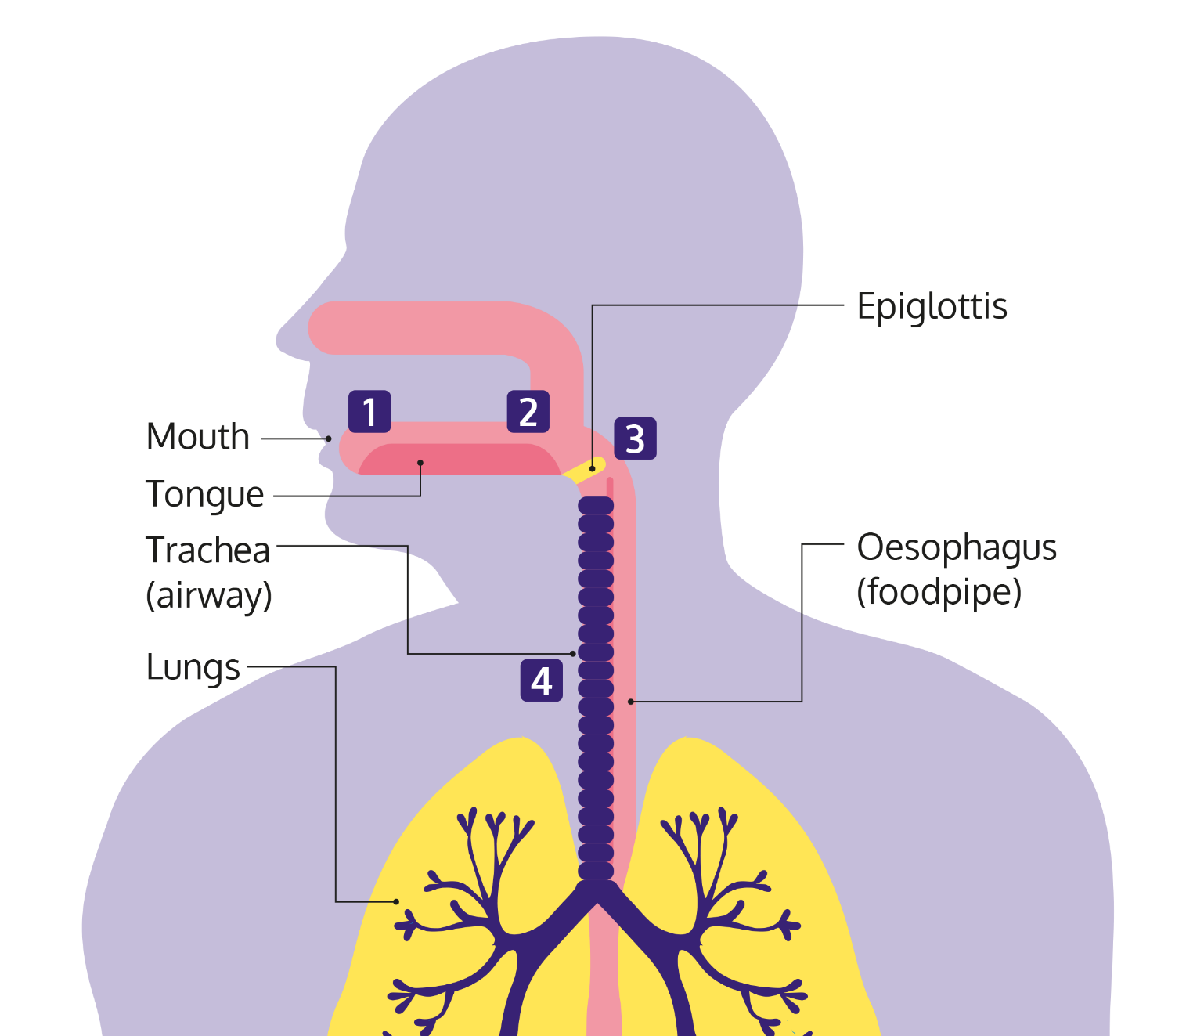

Are there treatments that can help?

Swallowing problems can get better and most people are able to swallow safely again within the first few weeks. A small number of people have problems that last longer than this. Only a very small number of people are left with lasting difficulties.

Even if you are left with permanent difficulties, they do not have to stop you from doing what you want to do. Most people find they’re still able to live full lives. But it may take some time to adjust to the changes that you need to make.

If you have problems with swallowing, you should be referred to a speech and language therapist, who will work with you to try to improve them.

Your speech and language therapist will complete an assessment with you, to work out exactly what’s going on. Once they know this, they’ll be able to talk to you and your family about the best ways to treat or manage your swallowing difficulties.

To begin with, the most important thing will be making sure that you can swallow safely. Your speech and language therapist will explain the different things you can do.

This could include:
- Changing how you eat and drink.
- Learning techniques that can help you to swallow.
- Using aids that can help you to eat or drink more easily.

As well as these, your speech and language therapist may also get you to practise exercises to strengthen muscles in your throat, face and mouth. This may help you to swallow better and protect your airway.
Visit stroke.org.uk/swallowing for more information on
swallowing treatments.

‘Speech and language therapy helped me with my swallowing.’
- Colt, stroke survivor

Changing how you eat and drink
If you cannot swallow safely, then you’ll probably need to make changes to your diet with advice from a speech and language therapist.

Drinking safely
It’s important to drink enough, because your body needs to stay hydrated to fight off infections and help you recover from stroke. Water and other thin liquids are the hardest things to swallow because they’re difficult to control once they enter your mouth. Your therapist might assess you and discuss if using thickened drinks may be of benefit to you. These can be made using special powders to create the right level of thickness.

To make thicker liquids more enjoyable to drink, you might be able to try chilled or flavoured drinks. Making sure the drink is freshly prepared, and not thicker than it needs to be, could make it more pleasant to drink. Your therapist may be able to suggest how to make some regular drinks to the right consistency, such as smoothies or milkshakes.

Eating soft or pureed food
If you have problems with chewing and swallowing, you may need to eat soft food. There are different categories of food softness, from soft and bite-sized through to liquidised. A speech and language therapist can advise you on the right texture.

Change the temperature
Hot foods and drinks can be difficult to swallow because you cannot hold them in your mouth as long. Your therapist may suggest that you stick to cold foods, or allow hot food to cool down quite a bit before you try to eat it.
Change how and when you eat
Eating small amounts throughout the day, rather than three big meals, for example, may be better for you if you’re finding it hard to concentrate or you get tired very quickly. You may also find small portions are easier to manage, or that eating earlier in the day when you have more energy works better.

Your speech and language therapist will explain to you and your family exactly what foods are safe for you to eat. They’ll also make sure the rest of your stroke team are clear about what you can and cannot eat, and how you should be eating. Your stroke team should discuss any recommendations with you and involve you in making decisions.

Some people make a good recovery from swallowing problems. The way you eat, and what you are able to eat and drink, may change over time as you go through your recovery. You might be able to go back to eating more of the foods you are used to.

If your swallowing problems are long-term, with good care and support, you can have a good diet and enjoy your food and drink.

Getting on with life with swallowing problems

Just because you have swallowing problems, it does not mean you cannot enjoy eating. If you’re missing your favourite meals and snacks, speak to your speech and language therapist or dietitian. There may be a way for you to have them or to enjoy something similar.

Many types of everyday food are soft or can be made in soft or pureed form. Ask your dietitian for advice about dishes you might be able to make at home and how to make them tasty and enjoyable. If you enjoy your food, it can help you to get the energy and nutrients you need to stay healthy.

Soft foods do not have to be boring. There are lots of cookery books and online recipes for tasty pureed meals. Or if you’re not able to cook, there are companies that will deliver meals to you that look and taste great. Ask your speech and language therapist or dietitian if they have any recommendations.

Medication comes in different forms, including liquids, patches and inhalers. If you’re finding it hard to swallow your tablets, speak to your doctor or pharmacist to see if your medication comes in a different form that may be easier for you to take. Always check with your pharmacist first before crushing tablets, as this can change the way some medications work and can even be dangerous.

Swallowing assessments
You’ll probably have a number of swallowing assessments while you’re in hospital, to check how your swallowing improves over time.

Your therapist will usually begin by asking you to swallow a very small amount of water, followed by food and drinks of different consistencies, to show whether you can swallow them safely.

A videofluoroscopy involves taking video x-rays of your mouth and throat while you swallow. You will sit beside an x-ray machine and be given different foods and drinks to swallow. These will be mixed with a special liquid called barium that will show up on the x-rays.

A fibreoptic endoscopic evaluation of swallowing (FEES) uses an endoscope to find out what’s happening when you swallow. An endoscope is a long, thin, flexible tube that has a light and a tiny camera at the end of it. It’s inserted into one of your nostrils and down your throat, so that your therapist can see how well your muscles are working and where the problems may be occurring.

You can ask for another assessment if you think your swallowing has changed.

If you’re not able to swallow, you may be given fluids through a drip into a vein, to make sure that you do not become dehydrated. It’s also important you get the right nutrition, so your stroke team may also talk to you about being fed by a tube.

Tube feeding
If your swallowing problems make it hard for you to eat enough, you might lose weight and miss out on important nutrients. This can cause low energy levels and even slow down your recovery. If this happens, you might be offered tube feeding. Tube feeding means putting liquid food directly into your digestive system through a tube. This is also known as enteral feeding. You might only need it for a short time if your swallowing improves, but some people will need it for longer.

There are different types of feeding tube. The two that are used most often after a stroke are nasogastric (NG) tubes and percutaneous endoscopic gastrostomy (PEG) tubes.

NG tubes go through the nose into the stomach. They tend to be temporary and are normally used if you’ll need to be tube fed for less than four weeks. A PEG tube is inserted into the stomach through a hole in your skin. They tend to be used for longer periods.

After some time using an NG tube you are thinking of changing to a PEG, you’ll need to talk through both options with your stroke team and family, to decide which one is best for you. There are advantages and disadvantages to both. Your stroke team should discuss any benefits and risks with you.

Nasogastric (NG) tube
A very thin tube, not much wider than a piece of spaghetti. It goes up your nose, down the back of your throat and into your stomach.

Advantages include:
- Easier to insert than a PEG tube, as it’s less invasive.
- Easy to remove.
- No need for sedation.

Disadvantages include:
- Can be uncomfortable when it’s in place.
- Can fall out easily, so it may need to be replaced regularly.
- Some people do not like how it looks.

Percutaneous endoscopic gastrostomy (PEG) tube
A tube that is inserted directly into your stomach, through your skin.

Advantages include:
- Rarely falls out.
- More comfortable.
- Can be hidden under your clothes.

Disadvantages include:
- More difficult to replace if it does fall out.
- You will be given a sedative when it’s inserted, and a doctor or nurse will explain the risks to you.
- The area around the tube can become infected.

Tube feeding at home
If your overall recovery is good, then your stroke team may suggest you go home and continue the tube-feeding at home. This can worry some people as they think it can be a lot to cope with.

However, most people cope very well with tube feeding at home, even people who live on their own. Once you’ve given it a go, you’ll probably find it’s not as difficult as you thought.

Some reasons to consider tube feeding at home:
- Feeding machines are usually very easy to use.
- You and your family will be shown exactly what to do before you go home.
- You’ll have support from community nurses once you’re home.
- You can always consider other options later, if you do find it too much.

It’s up to your stroke team to make sure you and your family have all the information, support and equipment you need before you go home. You’re likely to have lots of questions. The earlier you get the answers, the more confident you’ll feel about going home.

Questions to ask before you go home
- How do I use the feeding machine?
- How do I know if the tube is in place?
- Will I still be able to eat using my mouth if I want to?
- What do I do if the tube becomes blocked?
- Do I have to clean the machine? How do I do it?
- Are there written instructions I can have?
- How do I get more food?
- Who do I contact if I have a question?
- Who do I contact in an emergency?

Although life with tube feeding can take some getting used to, it does not have to stop you from doing things that you want to do. Over time, you’ll adjust to the changes you need to make. With a little extra planning, you’ll still be able to enjoy things like going out and going on holiday.

Who can I ask about tube feeding?
You will have individual help and advice about tube feeding in hospital and at home. Health professionals who support tube feeding include nurses, dietitians and pharmacists, but job titles can vary between areas. The main professionals who help you are:
- Dietitian.
- Specialist nutrition nurse.
- District nurse or community nutrition nurse: support at home.
- Pharmacist: help with prescriptions for feeding supplements and medications.
- Speech and language therapist: advice if you are also having food by mouth or planning to go back to eating.

What can I do about swallowing problems?

Listen to your therapist
The most important thing is to follow the advice your speech and language therapist gives you. Even though you may think that you’re able to swallow safely, you cannot know for sure.

Not being able to eat the things you enjoy is difficult, especially when you’re in hospital or if you’re feeling down. However, avoiding difficult foods, however much you miss them, will help you recover.

Ask questions
It’s important you understand the instructions and advice you’re given. Ask your speech and language therapist to explain things again if you need them to.

Don’t worry if you feel that you’re always asking questions. Your stroke team would much rather you ask than do something that puts yourself at risk. So if you want to eat something but you’re not absolutely sure it’s OK, double check. Or if you think your swallowing has improved, ask for another assessment so you can be sure.

Learn how to swallow safely
Although your speech and language therapist will show you, our swallowing dos and don’ts can remind you how to swallow safely.

Do
- Create time and space for you to concentrate on what you’re doing. Turn off the TV or draw the curtain round your hospital bed.
- Sit up with a straight back, arms and hands forwards. If you are in a chair, keep your feet flat on the floor.
- Take your time.
- Take small amounts. Cut food up into small, bitesize pieces and just take small sips when you drink.
- Swallow twice after each mouthful, to make sure nothing is left in your mouth.

Don’t
- Try to eat or drink if you’re feeling tired or drowsy.
- Try to eat or drink lying down.
- Talk while you’re trying to swallow.
- Use straws or cups with spouts unless your speech and language therapist has told you it’s safe.
- Eat foods with a variety of textures, such as soup that has large chunks in it or cornflakes with milk.

Look after your mouth and teeth

You should have help and support to look after your mouth, because the bacteria (germs) in your mouth can be aspirated into your lungs.

When there’s a build-up of bacteria in your mouth after a stroke, it raises the risk of pneumonia. Regularly cleaning inside your mouth, including your teeth and gums, reduces the amount of bacteria and may lower the risk of pneumonia.

Traces of food in your mouth can also lead to gum infections or tooth decay, making your mouth sore and making it harder to eat and drink.

Here are some tips to help:

- Ideally, you should brush your teeth and clean your dentures after every meal. Try to aim for at least twice a day if you can, including before bedtime at night. You may need help with this. Try to establish a routine in hospital and maintain it when you get home.

- Your nurse or your speech and language therapist should show you the safest way to clean your teeth, tongue and mouth. They can also show a family member or carer how to help. Non-foaming toothpaste helps reduce the risk of aspiration.

- Make sure you use a toothpaste with high levels of fluoride (at least 1350ppm fluoride) and that your toothbrush is dry before you start to use it. You do not need to rinse out your mouth with water after you have finished brushing.

- As well as your teeth, it’s important to clean your mouth and tongue. You can do this with a soft brush and some toothpaste.

- Any dentures should be taken out overnight and cleaned regularly after eating.

- Avoid sugary drinks and snacks, as these will damage your teeth. If your dietitian advises you to eat sweet foods, clean your teeth carefully after eating. Food supplements can also increase your chance of developing tooth decay, so clean your teeth or rinse your mouth with water after taking them.

- It’s important to keep your mouth moist. Even if you cannot drink, you may be able to use a saliva spray or special gel to stop your mouth from getting dry. Ask your speech and language therapist.

- Use lip balm to stop your lips getting dry or cracked.

- Make sure you know what you need to do before you go home. If you’re still having some problems with swallowing, make sure you have any special equipment or products you need to keep your teeth and mouth clean.

- Make sure you’re registered with a dentist and see them regularly. They can check your teeth and mouth are healthy and give you any advice you need. You may also need new dentures or to have your current ones adapted to help you put them in and take them out. If you cannot get to your dentist’s surgery, ask whether they can visit you at home.

Talk to someone about it
Swallowing problems can be especially difficult to cope with at home. A large part of our family and social lives is about eating and drinking, so it can have a big impact when you’re not able to enjoy these things anymore. Many stroke survivors say they feel left out when they’re not able to take part in family meal-times like they used to. Or you may not look forward to meals out, because you feel embarrassed to eat in front of other people or feel awkward if you’re not eating with everyone else.

These feelings can take their toll. So make sure you talk to someone about them. Support groups can be helpful, because you can talk with people who are going through the same thing. Or talk to a friend or family member instead if you feel more comfortable with this. You can also call our Stroke Support Helpline if you need someone to talk to.

Tips for family and friends

It can be difficult to know how to help someone with swallowing problems. Here are some tips to help you.

Always check
It’s difficult to know what helps and what does not when it comes to swallowing. A straw, for example, may seem pretty harmless. However, most people with swallowing problems should not use them. It should be OK to bring in food or drinks for someone in hospital, but double check it’s safe with a health professional in the stroke team first.

Don’t ignore advice
The best way to help your friend or family member is to make sure they stick to the advice they’re given. You may be worried they’re going hungry or that not being able to eat is getting them down. Talking to their speech and language therapist should help to put your mind at ease. Together, you may be able to think of something you can do to help the person feel better.

Give them time and privacy
Swallowing problems can make people feel very self-conscious. So make sure your friend or family member has some privacy when they’re eating. For example, pulling the curtain round their hospital bed or asking visitors to pop out while they eat. Time is also really important. Eating probably feels stressful enough for them, so rushing is only going to make it worse. Encourage them to take their time and enjoy their food.

Ask for help if you need it
Coping with swallowing problems can feel very overwhelming. So don’t be afraid to ask for help. Before your friend or family member is discharged from hospital, make sure you know who you can contact if you have a question once they’re home. Talk to your GP if it’s getting too much and ask what support you can get.

It may also help to talk to someone else about it, especially someone who’s been in a similar situation. There may be a carers’ group or local stroke club in your area. You can also call our Stroke Support Helpline.

Swallowing dos and don’ts
When you’re helping someone to eat or drink, try to remember these simple dos and don’ts.

Do
- Make sure they’re sitting up straight. A pillow may help support their trunk if they are leaning to one side.
- Allow plenty of time.
- Show them what they’re about to eat or describe it to them. Eating is just as much about how the food looks and smells as how it tastes.
- Try to present food so it looks nice. Be positive and encouraging when you offer it. Keeping food separate on the plate is much more appetising than mashing it all together. Food moulds can also help you to present pureed food nicely.

Don’t
- Give them a drink or something to eat if they are feeling tired or drowsy.
- Rush them or offer too much at once.
- Move from one food to another without asking them.
- Forget that you’re helping an adult, not a child.

Where to get help and information

From the Stroke Association

Stroke Support Helpline
Our Stroke Support Helpline offers information and support for anyone affected by stroke, including family, friends and carers.
Call us on 0303 3033 100, from a textphone 18001 0303 3033 100
Email helpline@stroke.org.uk

Read our information
Log onto stroke.org.uk, where you can find easy-to-understand information, videos and an online community to support you. You can also call the Helpline to ask for printed copies of our guides.

Other sources of help and information

Association for the Rehabilitation of Communication and Oral Skills (ARCOS)
Website: arcos.org.uk
Tel: 01684 576 795
A charity that supports people who have problems with eating, drinking and swallowing, as well as communication.

MyTube
Website: mytube.mymnd.org.uk
A website for people using tube feeding and their carers. It includes videos, personal stories and practical information about tube feeding.

Patients on Intravenous and Naso-gastric Nutrition Treatment (PINNT)
Website: pinnt.com
Tel: 020 3004 6193
A support group for people who are use artificial nutrition. They offer information, regular newsletters and opportunities to meet other members.

About our information
We want to provide the best information for people affected by stroke. That’s why we ask stroke survivors and their families, as well as medical experts, to help us put our publications together.

How did we do?
To tell us what you think of this guide, or to request a list of the sources we used to create it, email us at feedback@stroke.org.uk

Accessible formats
Visit our website if you need this information in audio, large print or braille.
Always get individual advice
This guide contains general information about stroke. But if you have a problem, you should get individual advice from a professional such as a GP or pharmacist. Our Helpline can also help you find support. We work very hard to give you the latest facts, but some things change. We don’t control the information provided by other organisations or websites.

© Stroke Association 2025.
Version 6. Published: June 2025
To be reviewed: September 2027
Item code: A01F05

The Stroke Association is registered as a charity in England and Wales (No 211015) and in Scotland (SC037789).
Also registered in the Isle of Man (No. 945) and Jersey (No. 221), and operating as a charity in Northern Ireland.

