How to reduce your risk of a stroke

Active steps everyone can take.

This guide is for anyone who wants to reduce their risk of a stroke. This includes people who have already had a stroke.
Family members and friends supporting someone after a stroke may also find this information useful.

Contents
- About stroke Page 2
- Your risk of a stroke Page 4
- Reducing your risk of a stroke Page 7
- Spotting the signs of a stroke Page 31
- How the Stroke Association can help Page 34
For more information on reducing your risk of a stroke, visit our website at stroke.org.uk/stroke/manage-risk

About stroke

A stroke happens when the blood supply to part of the brain is cut off, killing brain cells. Damage to the brain can affect how the body works. It can also change how you think and feel.

There are two main types of stroke:
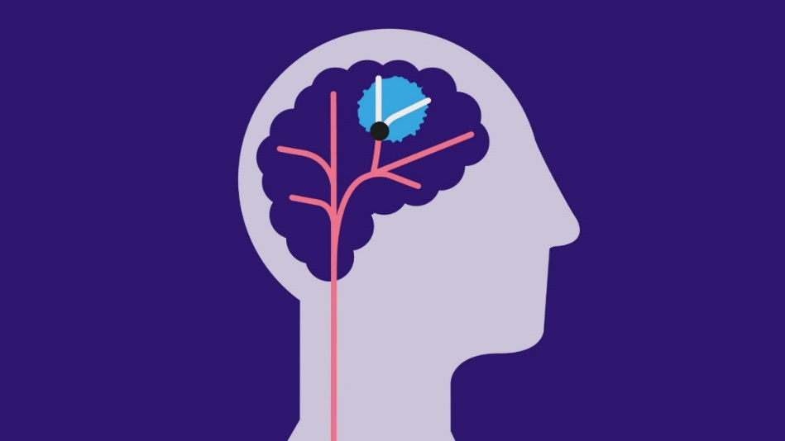
- Ischaemic stroke: due to a blocked blood vessel in the brain.

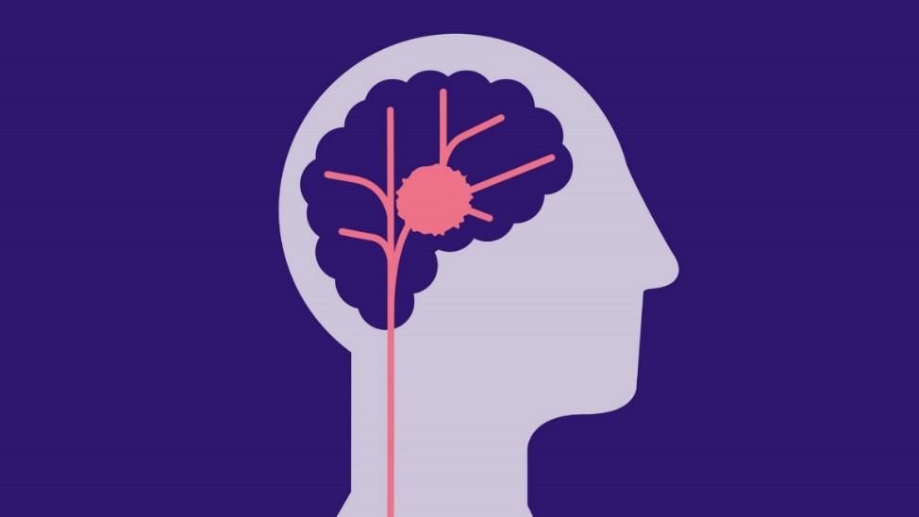
- Haemorrhagic: due to bleeding in or around the brain.
Turn to page 28 for information on spotting the signs of a stroke.

Your risk of a stroke
Everyone has a different risk of having a stroke, which depends on the unique risk factors that belong to them.

Risk factors are things which can make you more likely to have a stroke. They can include things about you and your lifestyle, like your age, a health problem or whether you smoke.

If you have had a stroke or TIA (transient ischaemic attack or mini-stroke), your risk of having another stroke is increased. But understanding what factors may have caused your stroke will help you know how you can reduce your risk of another. Healthcare professionals can give you advice about treating any medical conditions that could have led to your first stroke or TIA, such as high blood pressure.
They can also give advice and support with making
healthy lifestyle changes, such as stopping smoking
or eating more healthily.

The main risk factors for stroke

Age
Getting older increases your risk of having a TIA or stroke. But it can happen to anyone, at any age.

You can take active steps to reduce your stroke risk at any age. Have a look at our healthy living tips on Page 16.

Health problems
Some health conditions can raise your risk of a stroke. These include:

- High blood pressure.
- Atrial fibrillation (irregular heartbeat).
- Diabetes and pre-diabetes.
- High cholesterol.

Lifestyle
Stroke risk can be increased by things we do in everyday life, including:

• Eating food high in salt, fat and sugar.

• Being overweight.

• Being inactive.

• Smoking.

• Drinking too much alcohol.

Family history

Strokes can run in families. Speak to your GP or nurse if you have a close relative who has had a stroke. You may need some tests and health checks, and advice on reducing your risk.

Ethnicity
Strokes happen more often in people from South Asian, Black African and Black Caribbean families. Your GP can offer health checks and treatment for conditions such as diabetes and high blood pressure. These conditions are more prevalent in people from these ethnic backgrounds and are risk factors for stroke.

Reducing your risk of a stroke

Treat your health conditions

If you have a health condition linked to stroke, such as high blood pressure, sticking to your treatment can help you reduce your risk of having a stroke.

If you have already had a stroke or TIA, make sure you follow the treatment advised by your doctor for your health conditions. This is one of the best ways to reduce your risk of another stroke. This may involve taking medication and making lifestyle changes.

How to get your health checked
All the health conditions listed in this section can happen at any age. Even if you feel in good health, get a regular health check as these conditions do not always have noticeable symptoms.
Contact your GP surgery to ask for a health check. A pharmacist can also give advice and do some health checks.
NHS Health Check
In England, anyone aged 40-74 without pre-existing health conditions can have a free ‘NHS Health Check’. This looks for early signs of health problems, including stroke risk.

High blood pressure
High blood pressure plays a part in about half of all strokes. It’s the biggest single treatable risk factor for stroke.

What is high blood pressure? Your heart pumps blood through your blood vessels. When the blood presses too hard against the walls of the blood vessels, this is known as high blood pressure. It’s also called hypertension.

Why is it a risk? High blood pressure can lead to clots forming, or cause bleeding in the brain. High blood pressure can also increase the risk of heart attacks, vascular dementia and kidney disease.

How do I know I have it? It usually has no symptoms, so get your blood pressure checked regularly. You can get checked at your GP surgery or pharmacy. You can also buy a blood pressure monitor to use at home.

What can I do about it? If you are diagnosed with high blood pressure, making some healthy lifestyle changes can help and you may need medication. If you’re advised to take medication, it’s very important to take it regularly.

Visit stroke.org.uk/high-blood-pressure for more information.

Atrial fibrillation (AF)
If you have untreated atrial fibrillation (AF), your risk of a stroke is up to five times higher. A stroke can be more severe if you have AF.
What is AF? In AF, your heartbeat is irregular and may be abnormally fast.

Why is it a risk? The heart might not empty itself of blood at each beat, and a clot can form in the blood left behind. The clot can travel to the brain and cause a stroke.

How do I know I have it? You might feel your heart racing or beating irregularly, but some people do not get any symptoms. A GP or nurse can check you and send you for further tests.

What can I do about it? If you have AF and your stroke risk score is high, you may be given an anticoagulant (blood-thinning medication) to reduce your risk of a stroke. It’s important to keep taking any medication to reduce your risk.
Visit stroke.org.uk/stroke/managing-risk/atrial-fibrillation for more information.

Diabetes
Diabetes is estimated to lead to almost 1,000 strokes a week in the UK.

What is diabetes? Diabetes means your body cannot take the sugar out of your blood properly.

Why is it a risk? Too much sugar in your blood can lead to damage to the blood vessels. This increases the risk of having a stroke. It can also lead to heart attacks, vision loss and kidney problems.

How do I know I have it? Diabetes can make you need to wee more often or make you feel very tired and thirsty. But sometimes it has no symptoms. You can ask your GP about getting a health check. A blood test can confirm if you have diabetes or pre-diabetes. Visit nhs.uk/conditions/diabetes for more information on the symptoms of type 1 and type 2 diabetes.

What can I do about it? People with type 1 diabetes generally need insulin treatment. Some people with type 2 diabetes only need to make changes to their diet, while others need medication. Treating your diabetes and making healthy lifestyle choices, such as losing weight if you need to, can help you reduce your risk of a stroke.
See stroke.org.uk/diabetes for more information.

High cholesterol
High cholesterol is a major risk factor for stroke but many people don’t know they have it.

What is high cholesterol? Cholesterol is a vital substance in our bodies. But if there’s too much cholesterol in your blood, it can lead to heart disease and stroke. There are two main types. ‘Bad’ cholesterol can cause a build-up of fatty material inside your blood vessels. ‘Good’ cholesterol helps to reduce the levels of bad cholesterol.

Why is it a risk? Excess cholesterol in your blood can make the blood vessels clogged up with fatty material (atherosclerosis). This can lead to a clot forming which can cause a stroke.

How do I know I have it? High cholesterol does not usually have any symptoms. Your GP or pharmacist can do a blood test to check for it.

What can I do about it? Your cholesterol result can be used to calculate your risk of having a stroke. If your risk is high, you can try making lifestyle changes such as losing weight, being more active and eating healthily.

Statin medication is often given for high cholesterol and has been shown to reduce the risk of a stroke.
Some people are born with high cholesterol due to an inherited condition called familial hypercholesterolaemia. It’s vital to get tested if a relative had heart disease or stroke at an early age. It’s usually treated with cholesterol-lowering medication.

Other health conditions linked to stroke

Sickle cell disease (SCD)
Around a quarter of people with sickle cell disease (SCD) have a stroke before the age of 45. SCD is most common among people from African or Caribbean backgrounds, but cases also occur in people with heritage from the Middle East, parts of India, the eastern Mediterranean, and South and Central America.

SCD is caused by a gene that affects red blood cells. SCD raises the risk of a stroke because the red blood cells change shape, making them more likely to form clots.
It’s usually diagnosed during pregnancy or soon after birth with a blood test. Treatments to reduce the risk of a stroke may include medication or regular blood transfusions. Contact the Sickle Cell Society at sicklecellsociety.org for information and support.

Women’s contraception and hormone replacement therapy

Using the combined oral contraceptive pill or hormone replacement therapy (HRT) in tablet form can slightly increase the risk of stroke in women. Your doctor should assess your stroke risk before giving you these treatments. If you have certain health conditions or have had a previous blood clot or stroke, they may not be suitable for you. Your doctor can recommend alternatives if needed.

Overall, the risk of stroke from using the oral contraceptive pill or HRT tablets is low. Ask your doctor for individual advice about the benefits and risks and the best treatment for you. Do not stop any treatment without talking to a healthcare professional.

Stress and depression
Stress and depression have been linked with an increased risk of stroke. More research is needed to help us better understand why. One reason could be that it’s harder to look after your health if you’re depressed or under a lot of pressure. For example, some people might drink too much alcohol, smoke or eat unhealthy food if they feel down or stressed. This can lead to health problems like high blood pressure, which raise your risk of stroke.

Try talking to friends or family and seek support with your mental health from healthcare professionals. Being more physically active can often help with your emotional wellbeing too.

Visit nhs.uk/mental-health to find self-help guides and search for local support services.

Obstructive sleep apnoea (OSA)

A sleep disorder called obstructive sleep apnoea (OSA) is a risk factor for stroke. OSA interrupts your breathing during sleep. Some people with OSA snore, but not all. You might wake up a lot at night, make gasping or choking sounds while asleep, or feel very sleepy in the daytime. Speak to your GP if you think you have OSA as it can be serious if it’s not diagnosed and treated.

2. Make healthy lifestyle choices

You can help to reduce your risk of a stroke by making some healthy lifestyle
choices. Whether it’s your diet, activity levels, smoking or drinking, it’s never too late to make a change.

Get individual advice
Remember, this guide can only give general information. You should always get individual advice about your own health and any treatment you may need from a healthcare professional, such as a doctor, nurse or pharmacist.

Reduce your waist size
Being overweight makes you more likely to have a stroke. Obesity affects your body in many ways, such as raising the risk of high blood pressure, high cholesterol and type 2 diabetes, which are all linked to stroke.

Measuring your waist can be a useful indication of whether you’re carrying too much fat. See nhs.uk/health-assessment-tools for how to check your waist-to-height ratio and BMI.

BMI, or body mass index, gives an indication of whether you are a healthy weight for your height. A healthy BMI is between 18.5 and 24.9. The NHS advises if you’re from Asian, Chinese, Middle Eastern, Black African or African-Caribbean family backgrounds, you should aim for a lower BMI of 18.5 to 22.9

If you’re advised to lose some weight or make healthy lifestyle changes, see nhs.uk/better-health for tips, tools and support with healthy eating and exercise.

There are also weight-loss medications available on prescription from the NHS for people who meet certain criteria. It’s important to talk to your doctor first for individual advice on whether these treatments may be suitable and safe for you.

Eat healthily
1. Reduce salt
Eating too much salt can raise your blood pressure, which is a major risk factor for stroke. The most salt we should have in a day is about one level teaspoon (6g).

A lot of the salt many of us eat is hidden in everyday foods, including bread, cereal, stock cubes and processed meats like ham. Ready meals and takeaways are often high in salt too.
While cooking, try adding different herbs or spices to boost flavour instead of salt. At the table, taste your food before adding salt – you might not need it!

Some people like using low-sodium salt products to help them cut down. These products are not suitable for some people at risk of stroke, including those using medication that affects potassium levels. Check with your GP or pharmacist before using low-sodium salt.

Practical support for healthy eating
Shopping and cooking can sometimes be difficult if you have a disability or low income. If you need help finding support, call our Stroke Support Helpline on 0303 3033 100.

2. Reduce sugar
Having too much sugar can make you gain excess weight, which increases your risk of type 2 diabetes and stroke.

You should aim to eat no more than seven sugar cubes-worth (30g) per day. Just one can of fizzy drink can have more than nine cubes of sugar.

Like salt, a lot of sugar is hidden in foods. And it’s not only sweet food like biscuits and cakes. Savoury foods like baked beans, tomato ketchup and chutneys can be very high in sugar.

Hidden sugars in one serving of some everyday foods
One sugar cube = 4g sugar
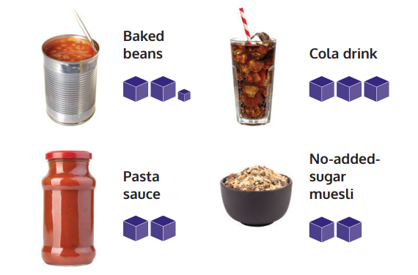

3.Eat less fat
Cutting down on fat can help you lose weight, which reduces your risk of a stroke.
You can help to reduce your cholesterol by eating less saturated fat and replacing it with a small amount of unsaturated fat. But if you have high cholesterol, you may need medication, so visit your GP.

Saturated fat is often a solid fat, such as butter. You’ll find it in foods like cheese, cakes, fatty red meat and sausages, as well as ghee, coconut oil and palm oil. Unsaturated fat is often an oil, such as olive oil or rapeseed oil. It’s also in oily fish, like salmon and sardines, and other foods like avocados, nuts and seeds.

For cooking, try replacing saturated fats like butter and coconut oil with small amounts of olive oil or rapeseed oil. Or grill, bake or steam food instead of frying with oil. You could try using lentils instead of red meat in dishes like curries and casseroles.

4. Boost your fibre
Eating foods with lots of fibre can help with weight loss, diabetes and heart health, which can reduce your stroke risk. Eating plenty of fruit and vegetables is a great way to get more fibre. Eat the peel on foods such as potatoes and apples.

Choose wholegrain or wholemeal varieties of foods like bread, pasta and rice. Add lentils, beans or chickpeas to curries and stews. Oats, unsalted nuts and seeds can also boost your daily fibre intake.

5. Balance your diet
Across the day, try to eat something from each of the food groups below. Home-made food made with fresh ingredients usually has less fat, salt or sugar than ready-made food or takeaways.
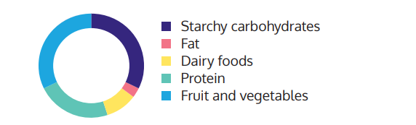
Fruit and vegetables: aim for five a day and go for a colourful variety. Tinned and frozen fruit and vegetables count and are often cheaper. Fruit and veg should make up about a third of your food each day.

Starchy carbohydrates: these include potatoes, yams, rice, bread, chapattis and pasta. Choose wholegrain or wholemeal varieties where you can. These can make up about a third of what you eat each day.

Protein is found in lean meat, fish, poultry, eggs and plant-based sources including dried beans, lentils and peas.
Dairy foods like milk, cheese and yoghurt provide calcium, to help keep bones strong. Try choosing lower-fat varieties. Plant-based sources of calcium include calcium-set tofu, cabbage and okra.

Fat contains the most calories per gram so you need very little. Try to use unsaturated fats like olive oil instead of saturated fats like butter.

Swallowing difficulties after a stroke
If you have swallowing problems after a stroke, you should have support from a dietitian or speech and language therapist to help you eat safely. See our guide ‘Swallowing problems after a stroke’ for more information.

Be as active as you can
Being physically active can help reduce your risk of a stroke and make a difference to your health. It can also help your emotional wellbeing by releasing chemicals into your brain that make you feel better. Aim to be active in some way each day and try to minimise time spent sitting down for long periods.

For some people, moving more could mean walking around the room or garden or doing some chair-based exercises. For others, it may mean swimming, gardening or joining an exercise class. Ask family or friends to encourage you or join in an activity, to help you get started and stay motivated.

Speak to your GP or physiotherapist first if you’ve not exercised for some time or have any concerns.
Visit stroke.org.uk/getting-active for tips on being more active.

“I started going to the gym. I’ve lost five stone and I’m not drinking really anymore. I’d like people to know you can recover and have a life after stroke.” – Damian, stroke survivor

Stop smoking
Smokers are around three times more likely to have a stroke than non-smokers. When you quit smoking, your risk starts to decrease right away.

Stopping smoking could be one of the best things you ever do for your health. There’s lots of help available. Visit nhs.uk/live-well/quit-smoking to find a free, local stop smoking service. You can also call these free helplines: England: 0300 123 1044, Scotland 0800 84 84 84, Wales 0800 085 2219.

Visit stroke.org.uk/smoking for tips on quitting.

E-cigarettes (vapes)
E-cigarettes may be helpful as part of a stop smoking plan. Unlike nicotine replacement therapy, e-cigarettes are not available on prescription. They’re not harmless, and it’s possible to remain addicted to vaping after quitting smoking. Get individual advice from a stop smoking service on how to use e-cigarettes to help you quit smoking.

Waterpipes
Different types of waterpipe include shisha, narghile, hookah and hubble-bubble. Despite sometimes being thought of as a ‘safe’ way to use tobacco, a waterpipe can deliver far more nicotine, smoke and harmful chemicals during a session than smoking a cigarette.

Cut down on alcohol
Regularly drinking too much alcohol raises your risk of a stroke. If you drink alcohol, you’re advised not to drink more than 14 units a week, spread out over at least three days in the week. Try to have several alcohol-free days each week.
Visit drinkaware.co.uk to find out how many units are in each of your drinks. There are also tips on cutting back and what to do if you’re worried about your drinking.

Illegal drug use
People may use illegal drugs without knowing about the risk of stroke. Drugs such as cocaine and methamphetamine can raise the risk of a stroke. Others, including cannabis, heroin and khat, have also been linked with an increased risk of stroke.

Drugs advice service FRANK provides information and confidential advice to drug users, their friends and family. Visit talktofrank.com or call 03001 236 600.

Spotting the signs of a stroke
It’s important to know how to spot the signs of a stroke in yourself or someone else. Using the FAST test can help you identify the three most common signs.

FAST test
Face: Can the person smile? Has their mouth or eye drooped?

Arms: Can the person raise both arms fully and keep them there?

Speech: Can the person speak clearly and understand what you say? Is their speech slurred?

Time: If you see any one of these three signs, it’s time to call 999.
The FAST test helps to spot the three most common signs of stroke. But there are other signs that you should always take seriously. These include:

- Sudden weakness or numbness on one side of the body, including legs, hands or feet
- Difficulty finding words or speaking in clear sentences
- Sudden blurred vision or loss of sight in one or both eyes
- Sudden memory loss or confusion
- Sudden dizziness, unsteadiness or a sudden fall.
- A sudden, severe headache.

Stroke can happen to anyone, at any age. Every second counts. If you spot any one of these signs of a stroke, do not wait. Call 999 straight away.

Transient ischaemic attack (TIA, or mini-stroke)
A TIA has the same symptoms as a stroke, but they last for a short amount of time. There is no way of knowing whether someone is having a TIA or a full stroke when the symptoms first start, so do not wait to see if the symptoms pass. Call 999 straight away.

Treating a stroke emergency
When someone has a suspected stroke, they should be taken to a specialist stroke unit in a hospital by ambulance. It’s vital to get stroke treatment as soon as possible.

How the Stroke Association can help

Stroke Support Helpline
Our Stroke Support Helpline is here to support anyone who has had a stroke, as well as their family, friends and carers. Our friendly, expert team can also answer any questions you might have about stroke.

Call us on 0303 3033 100.
From a textphone 18001 0303 3033 100.
Email helpline@stroke.org.uk

Read our information
Log onto stroke.org.uk, where you can find easy-to-understand information, videos and an online community to support you. You can also call the Helpline to ask for printed copies of our guides.

Other sources of help and information

NHS Better Health
Website: nhs.uk/better-health
Offers advice on healthy eating, losing weight, quitting smoking, reducing your alcohol intake, getting active, sleep and mental health.

British Heart Foundation
Website: bhf.org.uk
Helpline: 0808 802 1234
Information and support with heart health and heart conditions, including a helpline run by cardiac nurses.

Diabetes UK
Website: diabetes.org.uk
Helpline: 0345 123 2399
Information and support for anyone affected by diabetes.

About our information
We want to provide the best information for people affected by stroke. That’s why we ask stroke survivors and their families, as well as medical experts, to help us put our publications together.

How did we do?
To tell us what you think of this guide, or to request a list of the sources we used to create it, email us at feedback@stroke.org.uk

Accessible formats
Visit our website if you need this information in audio, large print or braille.

Always get individual advice
This guide contains general information about stroke. But if you have a problem, you should get individual advice from a professional such as a GP or pharmacist. Our Stroke Support Helpline can also help you find support. We work very hard to give you the latest facts, but some things change. We don’t control the information provided by other organisations or websites.

© Stroke Association 2026
Version 5. Published May 2026
To be reviewed: September 2028
Item code: A01L14

The Stroke Association is registered as a charity in England and Wales (No 211015) and in Scotland (SC037789). Also registered in the Isle of Man (No. 945) and Jersey (No. 221), and operating as a charity in Northern Ireland.

