My child has had a stroke

An introduction for parents and caregivers

Dear parent or caregiver,
If you’re reading this guide, you may be going through one of the hardest times of your life. Seeing your baby, child or teenager fall ill is difficult enough. Learning they have had a stroke is a further shock.
We are here to support you.
A diagnosis of stroke in a child is especially hard to understand and accept because many people believe that stroke only affects older people.
Parents who have been through this experience told us what they wished they had known when their child had a stroke. The result is this simple guide. It provides
information about childhood stroke, with details of where to go to find out more when you’re ready.
We understand the impacts of stroke are different for every child and family, and that they change as a child gets older.
That’s why our dedicated Childhood Stroke Support Team is here – to support you with guidance, emotional support, and practical information, whenever you need us.
Call us on 0303 3033 100 or email childhoodstroke@stroke.org.uk
As you read this, it may feel like your world has been turned upside down. Please remember you are not alone. We’re here to support you and your family.
Childhood Stroke Support Team

What is a stroke and how does it happen?
A stroke happens when part of the brain has its blood supply disrupted. Stroke can happen in a baby, child or teenager of any age. Your child’s doctors will try and find out if an underlying condition, like a heart or blood disorder, played a part. Sometimes, it’s not possible to find out what caused it.

The two main types of stroke
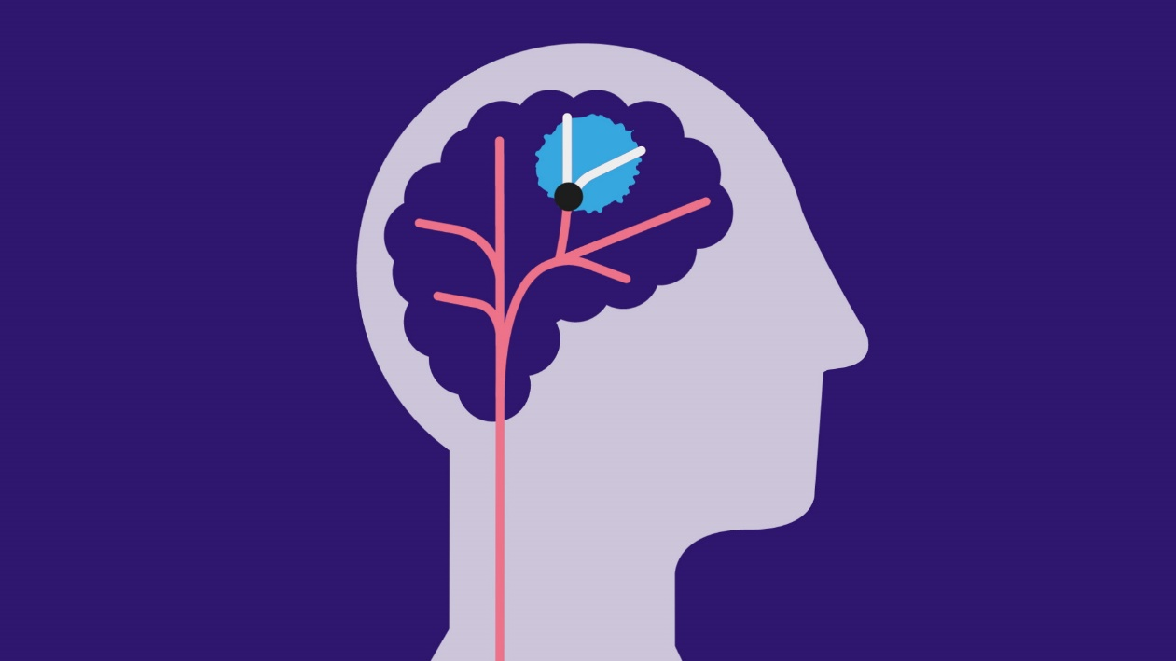
Ischaemic stroke: due to a blocked blood vessel in the brain (often called a ‘clot’).
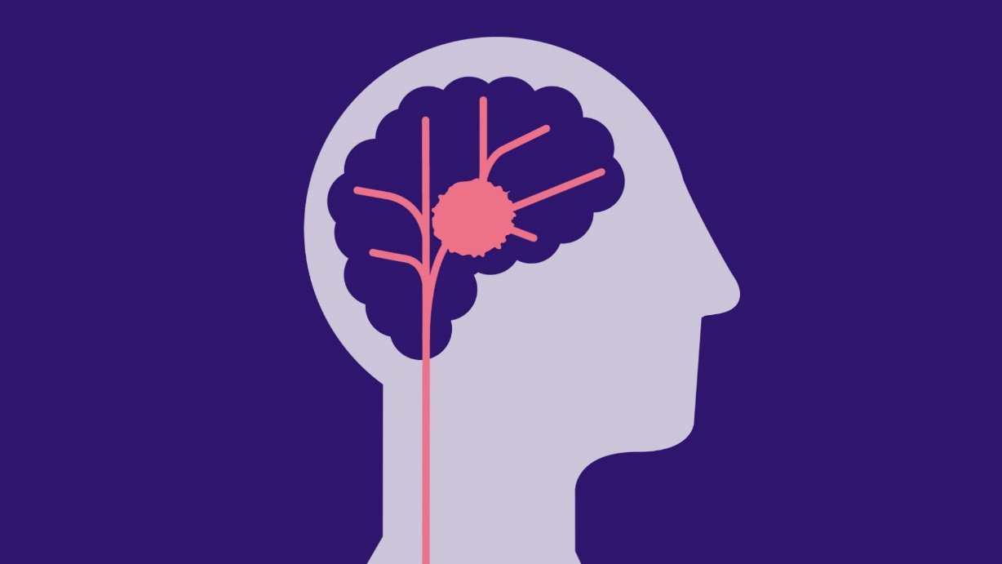
Haemorrhagic stroke: due to bleeding in or around the brain (often called a ‘bleed’).

The body image on the next page shows some of the problems that stroke can cause. Some of these will be temporary, while others may last longer.
Every stroke is different. Your child’s stroke and recovery are unique to them. Not every child will make a full recovery. But with the right support, they can make progress, build confidence and lead a happy life.
Possible effects of stroke on a child or young person
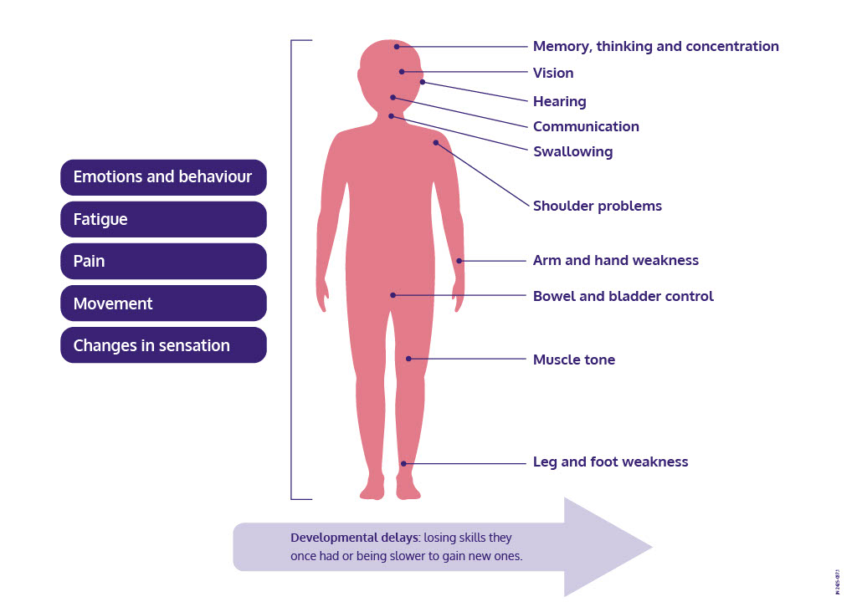

Visit stroke.org.uk/childhood for more information.
Your child’s brain is amazing!
Straight after their stroke, your child’s brain may start to rewire itself so they can recover skills. This process is called neuroplasticity. It begins after a stroke and can continue for years.

A child’s stroke journey
Healthcare support your child may receive after a stroke

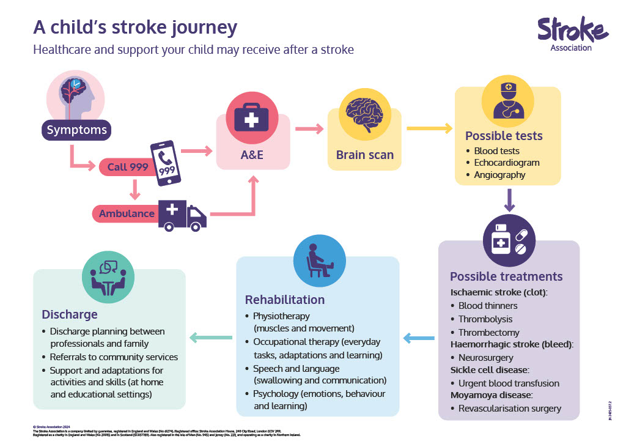

Coping with hospital life
In the early days and weeks after your child’s stroke, you
may spend a great deal of time at hospital. Your child may
have moved to a different hospital which provides specialist
care. Parents describe this as a surreal time where normal
life is completely put on hold.

As well as the initial shock of the stroke and fears about
your child’s health and future, you may be worried about
your other responsibilities. You may be missing other family
members or concerned about how this period will affect
your work or income. Here are some things you can try that
might help.

Talk to the healthcare team
You know your child better than anyone, so don’t be afraid
to ask questions or speak up. Talk through your worries and
play an active role in making decisions.
Understanding what is happening may also help you feel
more in control. This can be helpful in a situation where so
much is out of your hands.

Tip: Note down any questions you have about your child’s treatment or medical terms you don’t understand.
Find ways to help things feel normal
Where possible, continue familiar activities and routines
with your child. This could include reading a bedtime story,
playing games or watching TV together.

Look after yourself
Even if you don’t feel like it, try to eat healthily and get
some sleep, so you can be there for your child. Ask friends
to bring in whatever you need to feel comfortable or to stay
with your child for a while, so you can get outside for some
fresh air.

Talk to the discharge team
Before you leave, find out what ongoing healthcare
your child will receive and what will be available in the
community. This might include medication, therapy, care
and other support. If you’re worried about how you’ll cope,
talk to the team.

Reach out to others
Call our Childhood Stroke Support Team on 0303 3033 100.
You can talk to us about any questions or worries you may
have, however big or small. You might also find it helpful to
speak to one of our trained parent volunteers.
Visit the parent-run ‘My child had a stroke’ Facebook group to connect with other parents.

Practical tips
Others you care for: Think about who will look after anyone else who relies on you (including your pets) during this time.
Other commitments: Check your calendar. Are there any plans coming up you need to change?
Money: Find out about benefits and employment rights at Citizens Advice.
Education: Tell your child’s nursery, school or college what has happened, in case they need to plan for support or a phased return.
Visit stroke.org.uk/childhood for more information.

Going home
The healthcare team will discuss with you when your child is ready to be discharged from hospital. Going home is a huge milestone. But it’s not the end of the story. The next phase may bring a host of new challenges as you start to support your child with everyday life.

Adjusting to life afterwards
Flex routines
From work patterns to dinner time, life may look very different – at least for now. Try to be kind to yourself and take each day as it comes.
Family dynamics
Everyone in the family will need get used to any changes. If you have other children, try to spend some one-to-one time with them every day. Even 15 minutes a day can make a difference.
Coordinating care
You may need to allocate lots of time to coordinating appointments, delivering therapy and managing prescriptions. Setting up a folder will help you keep on top of the admin.
Lower expectations
When your child becomes more active again, start small and be flexible. If you tried going somewhere new and left early because your child was tired, see the experiment as a success.

Symptoms to look out for
It’s natural to worry that your child may have another stroke. Strokes in children are rare, but it’s important to know the warning signs of another stroke. For more information, go to stroke.org.uk/childhood and always call 999 if your child has any stroke symptoms.

What to tell people
Most people don’t realise children and young people can have a stroke. Many effects may be invisible or hard to notice. So, it may be hard for some people to understand how things have changed for you all. Some parents have experienced people thinking they are being overly anxious or precious about their child’s needs. You can always talk through any concerns with our Childhood Stroke Support Team.

Talking to your child
What you say will depend on how much your child can understand. Try to pick a time when you’re feeling calm. Keep your explanation simple and honest. Balance difficult news with positives. For example, remind them how much everyone loves them. Explain to older children that neuroplasticity is already building new connections in their brain (see page 5).

Talking to other family members
If you have other children, they will need help to understand changes at home, as well as changes in their brother or sister. Other people in your family may process information differently to you. They may find it easier to talk about it than you do, or may focus on solutions rather than feelings. Explore what works between you.

Talking to wider family and friends
Some parents gather strength from regular contact with their social network. If you find this draining, update people through a WhatsApp group or do a weekly email or social media post. Alternatively, nominate someone you trust to be your main point of contact with other friends.

Tip: It’s not usually clear exactly what a child’s recovery will look like. So, when someone asks about your child’s prognosis, this may be very painful. Explain clearly that you don’t know exactly what will happen and that you’re taking each day as it comes.

Looking after yourself
However mild or severe the effects of your child’s stroke are, and whatever recovery looks like for them, your child’s experience can have a huge impact on you and those around you.

Feelings parents said they had soon after their child’s stroke
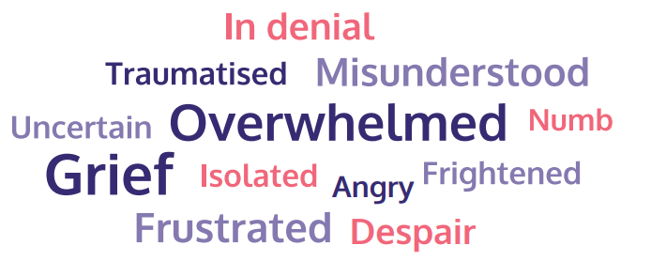

Some of the challenges you may face
Coping with uncertainty
For many parents, living with so many unknowns is the
hardest aspect of stroke.
Coping with multiple changes
Your lifestyle, routine, job and role as a parent may all
change overnight. This is a major shift, with no warning,
and it may take time to adjust.

Finding a balance
The intensity of care can become overwhelming. Do as
much as you can, while making sure your own and others’
basic needs are met too.

Managing services
Navigating healthcare appointments, as well as the benefits,
education and disability systems, can be stressful. You may
find you have to speak up for your child and their needs.

What can help
• Connect with others who have been through similar
experiences – through social media, groups or reading
people’s stories that offer hope.
• Think about how those around you could help – and let
them know.
• Embed regular routines that help you feel calm, such as
breathing exercises, meditation, essential oils, time out
for a cup of tea or spending time in nature.
• Think about how to keep doing some things that you
enjoy. These could include hobbies, creative activities,
exercising, watching your favourite TV show or spending
time with loved ones.

• Focus on your child’s progress, however small. Writing
down three positive things every day can change how
you feel about a situation.
• Talk things through at support groups or with a
counsellor.
• Remember, the Stroke Association is here for you too.
Call the Childhood Stroke Support Team on
0303 3033 100 or find us online at
stroke.org.uk/childhood

Know when to ask for help
If you find you’re often feeling low, overwhelmed or anxious, talk to your GP. Even if your main focus is your child, getting the support you need for yourself is crucial.

Where to get support and information
From the Stroke Association
Our Childhood Stroke Support Team can support you with practical information on a range of topics, answer questions or concerns, and provide emotional support or a listening ear – whenever you need us. Fill out a short form at stroke.org.uk/childhood and we’ll get in touch. Alternatively, you can call 0303 3033 100 or email childhoodstroke@stroke.org.uk
You might find it helpful to speak to one of our trained parent volunteers who understands what you are going through.
You could also attend ‘Learn and Chat’ sessions where you can hear from a healthcare professional who specialises in stroke in childhood. You can ask questions, chat with other parents and share experiences.
Our dedicated team can provide an online information session for teachers and school staff, to support them to understand more about childhood stroke, its impacts and offer practical tips for the classroom. Visit stroke.org.uk/childhood to find out more.
Our website also has more information about the causes and effects of stroke, as well as rehabilitation, recovery and returning to education.

Other sources of help and information
Bliss
Website: bliss.org.uk
Tel: 020 7378 1122
Emotional and practical support for families with babies born premature or sick.

Cerebra
Website: cerebra.org.uk
Tel: 0800 328 1159
Support and information for children with brain conditions and their families.

Child Brain Injury Trust
Website: childbraininjurytrust.org.uk
Tel: 0303 303 2248
Information, training, grants and counselling for anyone affected by childhood acquired brain injury.

Contact
Website: contact.org.uk
Tel: 0808 808 3555
Information, advice and support for children with additional needs.

Different Strokes
Website: differentstrokes.co.uk
Tel: 0345 130 7172
Information and support for teenagers and young adults affected by stroke, including befriending and groups.

IPSEA
Website: ipsea.org.uk
Tel: 0300 222 5899
Free legal advice on education for children with special educational needs and disabilities in England.

Sickle Cell and Young Stroke Survivors
Website: scyss.org
Tel: 0800 084 2809
Support and activities for children, young people and families affected by sickle cell disorders.

The Brain Charity
Website: thebraincharity.org.uk
Tel: 0151 298 2999
Support and social activities for anyone with a neurological condition, their families and carers.

UK guideline for treatment of childhood stroke
Find the ‘Stroke in childhood’ guideline, videos and more at rcpch.ac.uk/resources/stroke-in-childhood-clinical-guideline

About our information
We want to provide the best information for people affected by stroke. That’s why we ask stroke survivors and their families, as well as medical experts, to help us put our publications together.
How did we do? To tell us what you think of this guide, or to request a list of the sources we used to create it, email us at feedback@stroke.org.uk

Accessible formats
Visit our website if you need this information in audio, large print or braille.

Always get individual advice
This guide contains general information about stroke. But if you have a problem, you should get individual advice from a professional such as a GP or pharmacist. Our Stroke Support Helpline can also help you find support. We work very hard to give you the latest facts, but some things change. We don’t control the information provided by other organisations or websites.

© Stroke Association 2025 Version 1. Published February 2025 To be reviewed: April 2027 Item code: A01F48LP

